SUBCELLULAR STRUCTURAL CHANGES IN DIABETIC CARDIOMYOPATHY AND ITS IMPACT ON CARDIAC CELL CALCIUM DYNAMICS

Diabetic cardiomyopathy is characterized by reduced cardiac output and is linked to subcellular level changes in cell structure and function. Although studies a number of studies have quantified the effect on Ca2+ handling protein distributions and their kinetics, the alterations in spatial organization of the organelles have not been quantified before and nor has their effect on calcium dynamics been studied in an integrative manner. Cells from a healthy rat and a diabetic rat (adult, male wistar) were imaged under a transmission electron microscope. The spatial distribution of the mitochondria and myofibrils were analyzed in these images to determine a statistical model (using spatial statistics theory) that would adequately represent their characteristic distribution in health and diabetes. The model was then fitted to these cells to quantify the differences in spatial organization. We present these structural differences and assess the influence of these changes on the spatial and temporal dynamics of cytosolic calcium during calcium-induced calcium release in an integrative 3D computational model.

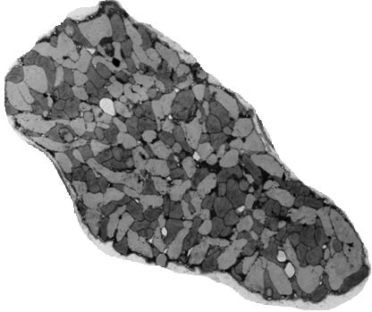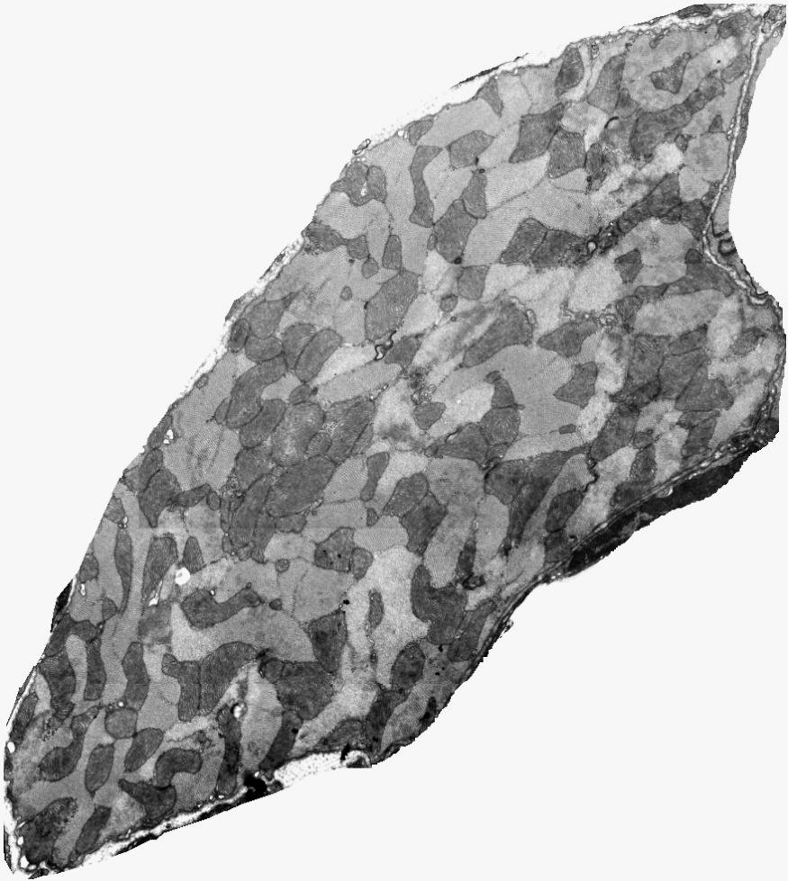
Figure 1: (Left) Healthy cardiac myocyte,(Right) Diabetic cardiac myocyte.

